NAAN MUDHAVAN



DOCUMENT



ASSIGNMENT



COURSE TITLE : DIGITAL MARKETING

COLLEGE CODE 1105

COLLEGE NAME : GOJAN SCHOOL OF BUSINESS AND TECHNOLOGY

NM ID : 9D715754644F780B3774B48FA69AB89D



NAME : TAMIZH SELVI K

REGISTER NUMBER 110520106339



YEAR : 4TH YEAR

DEPARTMENT : ELECTRONICS AND COMMUNICATION ENGINEERING

1. Create a blog or website using Blogspot and Wordpress. Customize the theme design and post new article with 500 words.

Link:https://premiumphotography0703.blogspot.com/2023/10/premium- photography.html?m=1

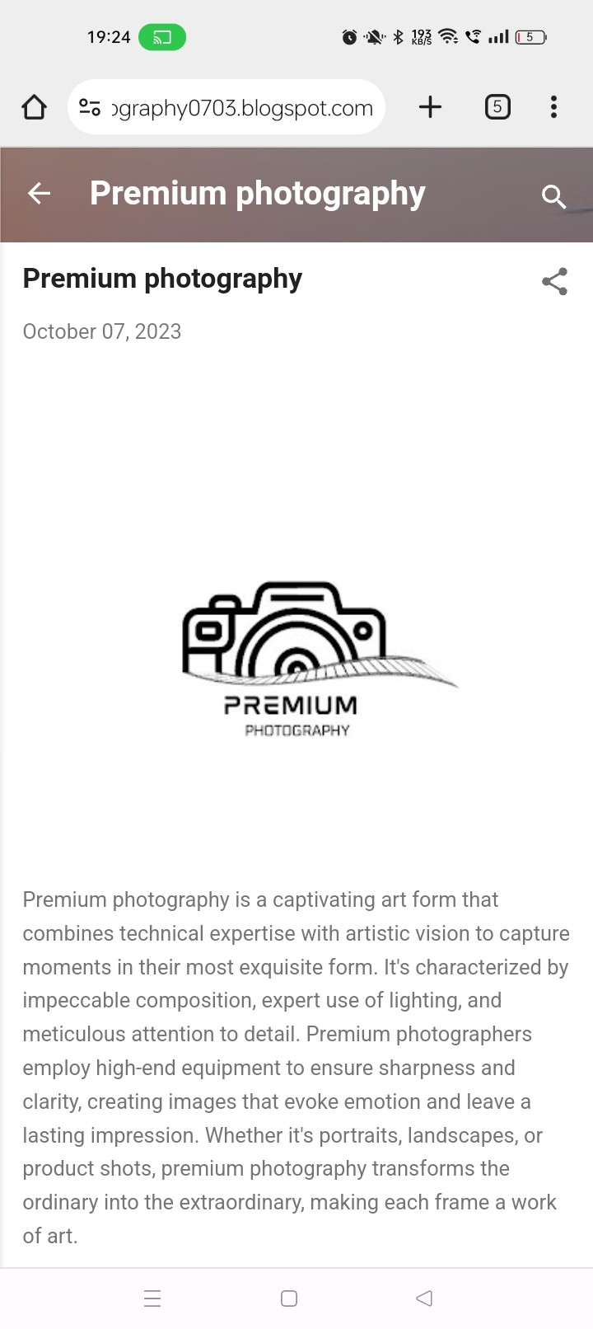

1. Create a New Facebook Business Page and post one social media poster for your brand.

Link: https://[www.facebook.com/profile.php?id=61551865120954](http://www.facebook.com/profile.php?id=61551865120954)

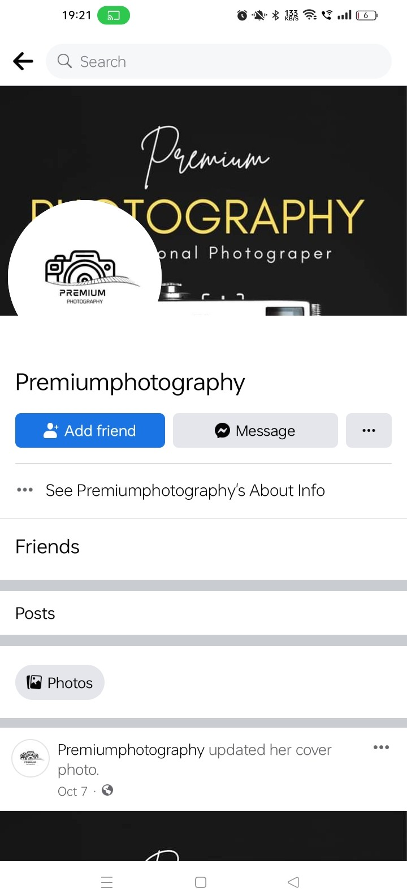

1. Create and design a social media advertisement poster using canva.



1. Create email newsletter design using MailChimp or canva tool.

Link: https://premiumphotography0703.blogspot.com/2023/10/premium- photography_63.html?m=1

